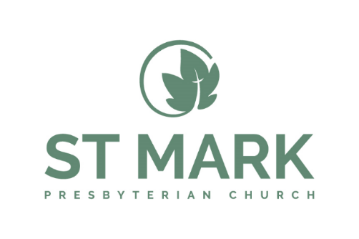
Summer Children/Youth Internship

Purpose Statement:
The Summer Internship is designed to grow faith, ministry and leadership skills.

The responsibilities of the intern will be as follows:
- Teach Sunday morning or Wednesday evening children and/or youth occasionally
- Shadow Youth Director to observe various aspects of youth ministry
- Support and attend various activities throughout the summer
- Plan for Fall activities by brainstorming and documenting ideas for youth programs
- Take advantage of every opportunity to speak, lead in worship, etc.
- Participate in weekly Youth Group meetings
- Report to work at the office, as required, for study & preparation time
- Assume full responsibility of the Youth Director in her absence
- Attend one Session leadership meeting
- Other duties as assigned

Role Requirements:
- A vibrant relationship with Jesus and a heart to serve people
- A commitment to the values and people of St. Mark Presbyterian Church
- The ability to self-lead in order to thrive in a fast-paced, collaborative environment
- Experience serving with students or kids is preferred

Education Requirements:
- Some college in related field (Youth Ministry/Christian Education, Early Education, etc) OR
- Experience in lieu of education

Skill Requirements:
- Proficiency with Microsoft Word and Excel

Part-Time: Approximately 30 hours per week paid
Pay: $15-18 an hour
Background check required

